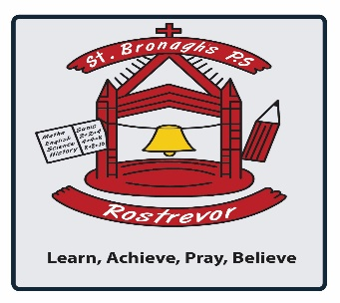

Dear Parent/Guardian,

I writing to update you about an important project that our school is going to be involved in. We have been given the opportunity to take part in a pilot project of ‘Operation Encompass’. We are one of around 76 schools taking part in the Newry, Mourne and Down area. Operation Encompass is a partnership between Police and Schools and is aimed at supporting children who are victims of domestic violence.

Operation Encompass started in England ten years ago and is now coming to Northern Ireland. It is very simple idea, but one that will help us to support and protect vulnerable children. When the Police attend an incident of domestic violence where one of our pupils is present, they will inform the school’s deputy designated teacher for child protection (Mr. Gallagher) at the start of the next school day. This information is shared in strict confidence, and school staff are only told on a need to know basis.

Following any notification from the police, our staff will provide immediate support to any child who has been the victim of domestic abuse. We know that when children do witness domestic abuse at home, this is a highly traumatic experience for them. By taking part in Operation Encompass we can provide tailored and compassionate support to our pupils, in line with our ethos. This builds on our existing commitment to child safeguarding and our school continues to be a “Safe Place” for victims of domestic violence.

Should you wish to find out more information, please contact the school’s Deputy Designated Teacher for Child Protection, Mr. Gallagher, or alternatively you can read more about Operation Encompass at www.operationencompass.org.

Signed

John Gallagher

Principal

