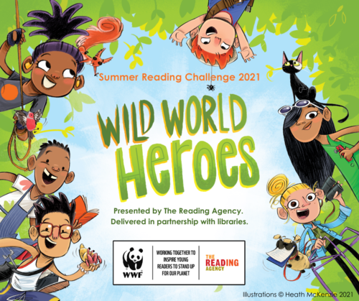

**Introducing the Summer Reading Challenge 2021**

Wild World Heroes, Summer Reading Challenge 2021; a celebration of nature and action for the environment, in partnership with WWF UK.

Arriving online and in libraries across Northern Ireland this summer.

**What’s it all about?**

Children age 4-11 can join the Wild World Heroes for this year’s Summer Reading Challenge to discover how they can make a difference to the environment and be inspired to stand up for the planet. There will be amazing books, awesome rewards and plenty of ideas too!

**How does it work?**

The Summer Reading Challenge will take place from 19 June until 18 September. Children can sign-up at their local library, choose their reading goal and then read any books to collect special stickers and other rewards along the way – all for **FREE.** There is a digital platform too so the fun can carry on at home.

Everyone who completes their personal challenge will receive a certificate and medal.

Events and activities will take place throughout the summer online and possible face-to-face depending on guidelines issued by the Northern Ireland Executive.

**Why should children take part?**

Children’s reading can ‘dip’ during the long summer holidays if they do not have regular access to books and encouragement to read for pleasure.

The Reading Agency’s annual Summer Reading Challenge really helps by getting over 700,000 regularly into libraries over the summer, with thousands more taking part online.

There is no other free reading activity that involves so many children, introduces families to their library, encourages children to read books freely and independently and is endorsed by parents and children.

Call us:   
0345 450 4580      |     [Find your nearest library](https://www.librariesni.org.uk/Libraries/)      |    [Send us a message](https://www.librariesni.org.uk/contact-us/)

[cid:image008.png@01D74CC3.715E2D10](https://www.facebook.com/LibrariesNorthernIreland)     [cid:image009.jpg@01D74CC3.715E2D10](https://twitter.com/librariesni)     [cid:image010.jpg@01D74CC3.715E2D10](https://www.instagram.com/librariesni/)    [cid:image011.jpg@01D74CC3.715E2D10](https://www.youtube.com/librariesni)