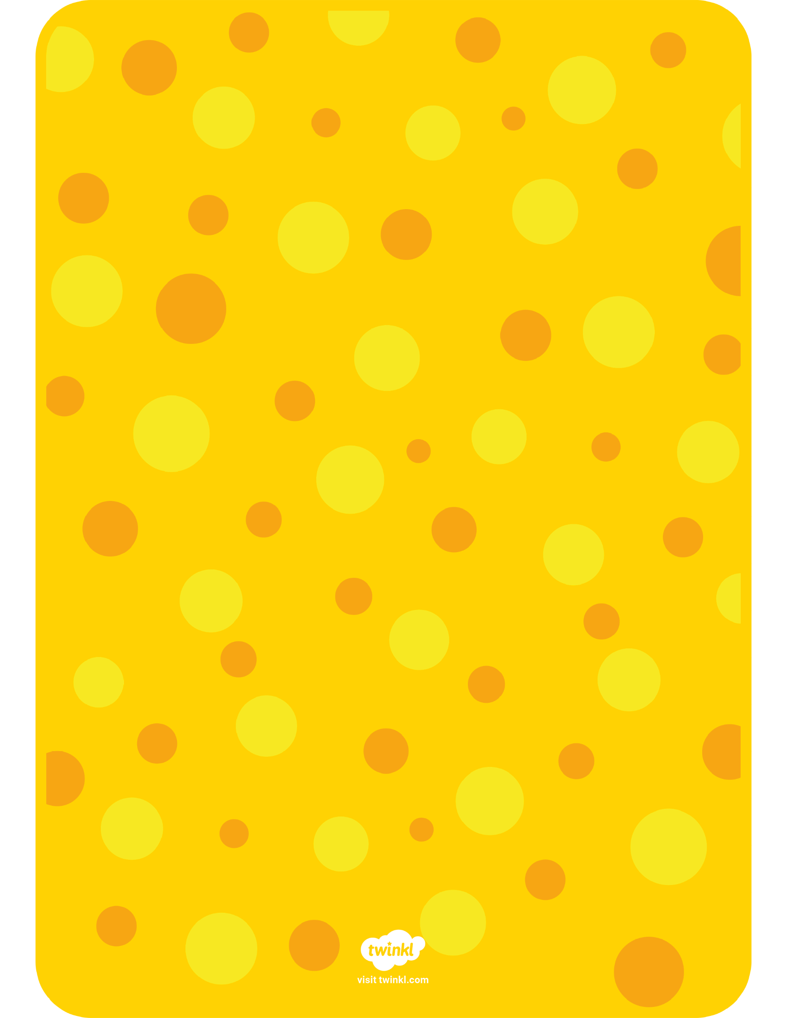

**PATHS Programme Thought For The Week.**

Our feelings are as much part of us as our hands, feet or hair. Feelings, while on the inside, often show on the outside. Everyone has feelings, so keep your eyes open and look out for how others are feeling.