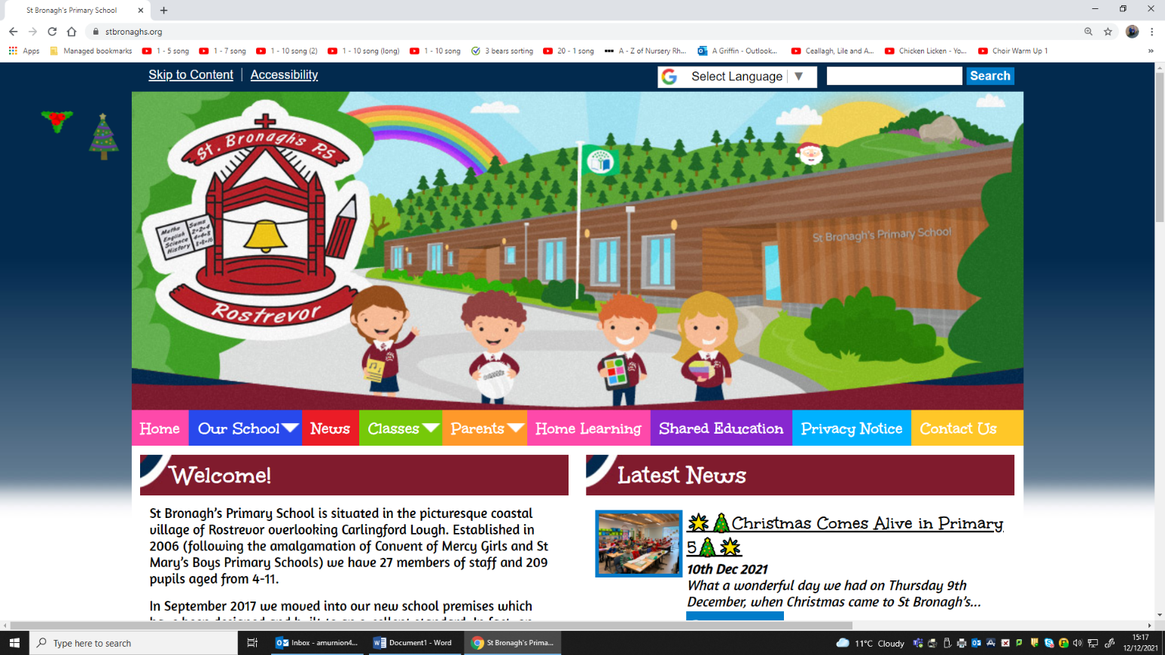

**St Bronagh’s Primary School, Rostrevor**

***‘Learn, Achieve, Pray, Believe’***

**School Admissions 2022**

**Key Dates**

**17th December 2021 Admission Criteria Published on the EA Website**

**10th January 2022 Online Applications Open**

**28th January 2022 Online Applications Close**

**28th April 2022 Notifications of Applications Outcome**

